Chapter 1 States of matter revision name: class:
1. 物质三态中微粒运动的快慢和微粒排列方式
Features | volume | fluidity | shape
solid | Fixed volume | Do not flow | Keep its own shape
liquid | Fixed volume | Flow easily | Take the shape of container
gas | No fixed volume | Flow easily | Take the shape of container
Kinetic particle theory 微粒的运动特征
Features | arrangement | distance | movement
solid | regular | Packed closely | Vibrate in the fixed position
liquid | irregular | Packed closely | Move around past each other
gas | irregular | Far apart | Move randomly

1.The arrangements of particles in solids, liquids and gases are different
Which statement about the molecules in ice, water or steam is correct? （ ）
A The H₂O molecules are on average closest together in steam.
B The H₂O molecules are on average furthest apart in water.
C The H₂O molecules in steam have the second highest average velocity.
D The H₂O molecules in ice are able to vibrate.

2. Which row describes the arrangement and motion of particles in a solid? （ ）
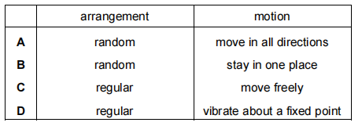
3. Sodium chloride is a liquid at 900 °C.
How are the particles arranged and how do the particles move in sodium chloride at 900 °C? （ ）
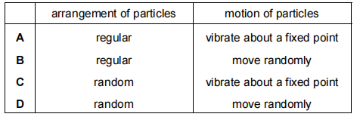
4. In which state does 1 dm³ of methane contain the most particles? （ ）
A gas at 100 °C
B gas at room temperature
C liquid
D solid

5. Use the idea of particles to explain why:
- solids have a definite shape

- liquids fill the bottom of a container

- you can't store gases in open containers

- you can't squeeze a sealed plastic syringe that is completely full of water

- a balloon expands as you blow into it.

2. Changes of states ，物质状态变化过程的名称，并从微粒排布的图像分析
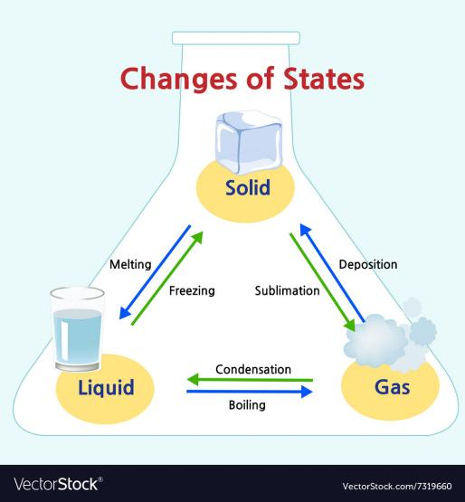

Solid liquid gas
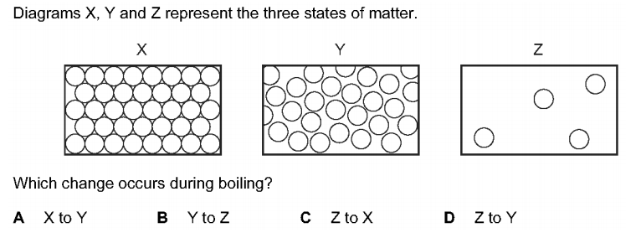


1. What are the processes W, X, Y and Z in the following diagram? （ ）
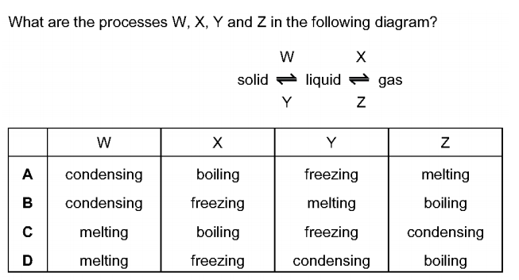

2. Diagrams X, Y and Z represent the three states of matter. （ ）
Which change occurs during boiling?
A X to Y B Y to Z C Z to X D Z to Y
3. In which process do particles move closer together but remain in motion? （ ）
A condensation B diffusion C evaporation D freezing

4. The particles of a substance gain energy and change from a regular ordered structure to a disordered structure with large distances between the particles.
Which change of state is described? （ ）
A boiling B evaporation C melting D sublimation

5. Which process causes the greatest increase in the distance between particles（ ）
A condensation B freezing C melting D sublimation

6. (c) Name the following changes of state.
(i) Ice turning into water.
.......................................................................................................................................
(ii) Solid carbon dioxide turning directly into gaseous carbon dioxide at room temperature.
.......................................................................................................................................
7. Matter can exist as solid, liquid or gas. The arrows show some changes of state.
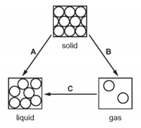
(a) Name the changes of state represented on the diagram.
(i) A ...............................................................................................................................
(ii) B ..............................................................................................................................
(iii) C ..............................................................................................................................
(b) Explain why energy has to be supplied to turn a liquid into a gas.
.......................................................................................................................................
.......................................................................................................................................
3. 从微粒排列与运动变化角度分析相变过程。
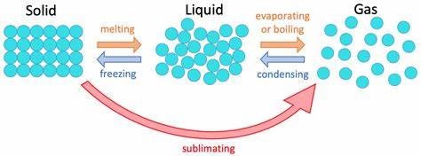
从solid 到liquid 到gas的过程中：1 Distance ↑ further apart 2. Movement ↑

1. A gas is heated. The pressure is kept constant.
Which statement describes the behaviour of the particles in the gas? （ ）
A The particles move faster and become closer together.
B The particles move faster and become further apart.
C The particles move slower and become closer together.
D The particles move slower and become further apart.

2. Pure water boils at 100℃.
What happens to the water particles when water boils? （ ）
A They gain energy and move further apart.
B They gain energy and stay close together.
C They lose energy and move further apart.
D They lose energy and stay close together.

3. A mixture of ice and water is left to stand and the ice melts.
Which row describes what happens as the ice is melting? （ ）
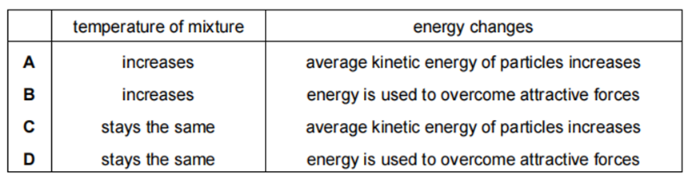
4. During the melting process of a substance, the temperature （ ）
A. Increases
B. Decreases
C. Stays the same
D. First increases then decreases

4. 根据Boiling points 与 melting points 的数值判断state (add : mp of mixture)
1.The melting points and boiling points of three elements, at 1 atm pressure, are shown.
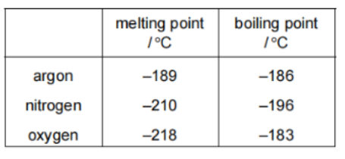
Separate samples of argon, nitrogen and oxygen are stored at -200'C and at 1 atm pressure
How many samples are liquids? （ ）
A.0 B.1 C.2 D.3

2. The melting points and boiling points of four elements are shown.
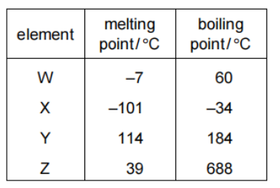
In which elements do the particles vibrate about fixed positions at 0 ℃? （ ）
A W and X B W and Z C X and Y D Y and Z

3. Gases are separated from liquid air by fractional distillation.
The boiling points of four gases are shown.
Which gas is both monatomic and a liquid at −200℃? （ ）
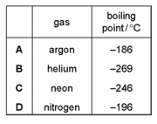

4.Pure ethanol has a melting point of –114 °C and a boiling point of 78 °C.
What are the melting and boiling points of a sample of ethanol with glucose dissolved in it? （ ）
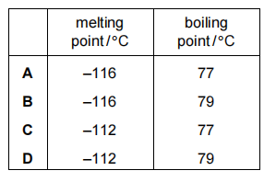
5. Heating curve and cooling curve(判断每个点中的物质状态和平台所对应的相变）
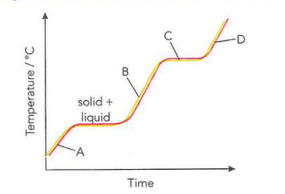
- In region A , B , D, the temperatrue ↑
→ The energy form heating is used to Increase the Kinetic energy
- When melting and boling, temperatrue stay constant(保持不变)
→ The energy form heating is used to break the attration force

1.The substance is heated to 80 °C and its temperature measured as it cools down
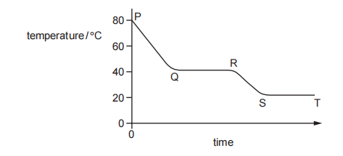
Between which times is substance M freezing? （ ）
A P to Q B Q to R C R to S D S to T

2. Look at graph for iron.
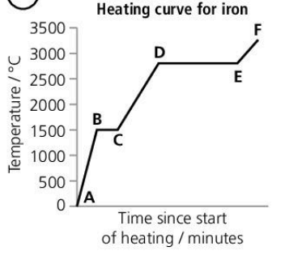
a What is happening between points D and E?

b Between which points is iron turning into a liquid?

c Give approximate melting and boiling points for iron.

3. Compound X is a colourless liquid at room temperature.
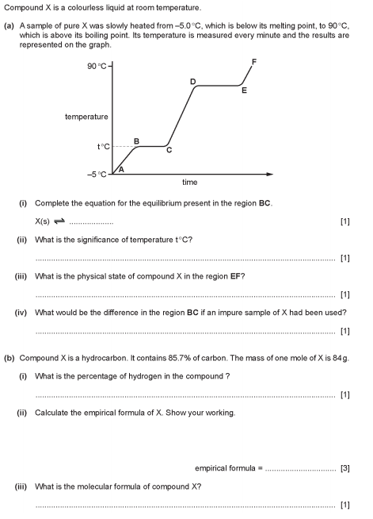
(a) A sample of pure X was slowly heated from −5.0 °C, which is below its melting point, to 90 °C, which is above its boiling point. Its temperature is measured every minute and the results are represented on the graph.

(i) Complete the equation for the equilibrium present in the region BC.
X(s) ⇌ ..................
(ii) What is the significance of temperature t °C?
......................................................................................................................................
(iii) What is the physical state of compound X in the region EF?
.......................................................................................................................................
(iv) What would be the difference in the region BC if an impure sample of X had been used?
.......................................................................................................................................

4. The graph shows how the temperature of a substance changes as it is cooled over a period of 30 minutes. The substance is a gas at the start.
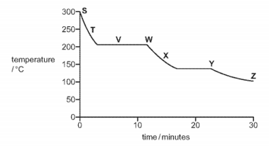
Each letter on the graph may be used once, more than once or not at all.
(a) Which letter, S, T, V, W, X, Y or Z, shows when
(i) the particles in the substance have the most kinetic energy,
.......................................................................................................................................
(ii) the particles in the substance are furthest apart,
.......................................................................................................................................
(iii) the substance exists as both a gas and a liquid?
.......................................................................................................................................
(b) Use the graph to estimate the freezing point of the substance. ......................... °C
(c) Name the change of state directly from a solid to a gas.
.......................................................................................................................................
6. Diffusion的定义
Diffusion: Particles move from a region of higher concentration towards a region of lower concentration, eventually, the substances get evenly spread.

1. A gas jar of bromine vapour and a gas jar of air are set up as shown in diagram 1.
The glass slide is removed. Diagram 2 shows the appearance of the gas jars after one hour.
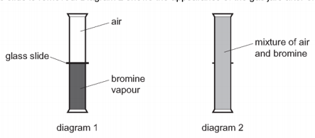
Which statement explains why the bromine and air mix together? （ ）
A Bromine is denser than air.
B Bromine is lighter than air.
C Bromine molecules moved upwards and molecules in air moved downwards.
D Molecules in bromine and air moved randomly.

2. The diagram shows a sugar lump in a cup of tea.
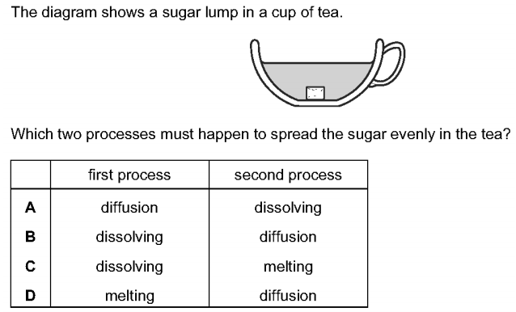
Which two processes must happen to spread the sugar evenly in the tea? （ ）


3. (a) Different gases diffuse at different speeds.
(i) What is meant by the term diffusion?
.......................................................................................................................................
.....................................................................................................................................
(ii) What property of a gas molecule affects the speed at which it diffuses?
.......................................................................................................................................
7. Rate of diffusion的影响因素：（temperature and relative molecular mass)
1.If the mass of particles is larger, the rate of diffusion will be （ ）
A. Faster B. Slower C. Unaffected D. First fast then slow

2. A gas is released at point X in the apparatus shown.
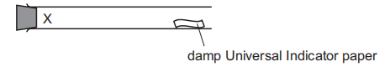
Which gas turns the damp Universal Indicator paper red most quickly? （ ）
A ammonia, NH₃
B chlorine, Cl₂
C hydrogen chloride, HCl
D sulfur dioxide, SO₂

3. Oxygen and fluorine are gaseous elements next to each other in the Periodic Table.
Under the same conditions of temperature and pressure, oxygen diffuses ......1...... than fluorine because its ......2...... is less than that of fluorine.
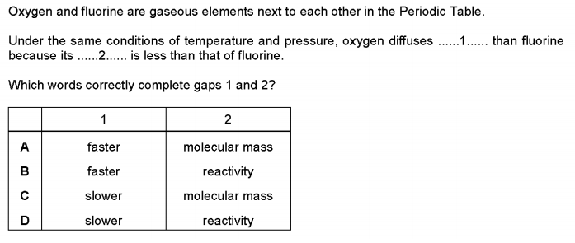
Which words correctly complete gaps 1 and 2? （ ）

4. Which statement explains why ammonia gas, NH₃, diffuses at a faster rate than hydrogen chloride gas, HCl? （ ）
A Ammonia expands to occupy all of the space available.
B Ammonia has a smaller relative molecular mass than hydrogen chloride.
C Ammonia is an alkali and hydrogen chloride is an acid.
D Ammonia molecules diffuse in all directions at the same time.

5. Gases diffuse, which means that they move to occupy the total available volume.
(i) Explain, using kinetic particle theory, why gases diffuse.
.......................................................................................................................................
.......................................................................................................................................
(ii) When the colourless gases hydrogen bromide and ethylamine come into contact, a white solid is formed.
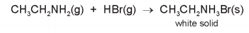
The following apparatus can be used to compare the rates of diffusion of the two gases ethylamine and hydrogen bromide.
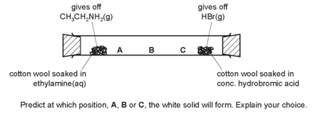
Predict at which position, A, B or C, the white solid will form. Explain your choice.
.......................................................................................................................................
.......................................................................................................................................

